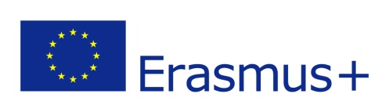 | What teachers said...
Hello Europe!  Welcome to the newsletter of the Erasmus+ project “A.L.I.V.E.” (Activating Leadership Initiatives through Values Education).  The aim of this newsletter is to keep you updated about the developement of our activities that will promote a more self aware, inclusive and leading youth, through the exchange of good practices among European schools in Norway, Romania, Portugal, Italy, Spain and Turkey.  The first meeting took place at our coordinating school in Norway, the Hadsel videregående skole og fagskole, from 26th to 30th November 2018.  During the meeting in Norway we made proper plans for sharing of tasks/responsibility throughout the project, according to our project plan, and we discussed how we share information and help each other doing these different tasks.  We had some training activities about leadership. In order to manage a project like this, we as a project group also need to attend our leadership skills. We discussed how to be a good listener and how to stay on topic in a project. And finally we had a team building activity, named Kahoot (online quiz).  Preparations for meeting number two, in Romania, were also done. We agreed on what to prepare and what to bring for this meeting. Also some practical issues needed attention and were dealt with.  In addition to these work sessions, we also had an introduction to The Norwegian school system, our local school and community. Students gave tours around the school and presented their student run businesses’. We visited a local salmon factory «Nordlaks» and a local gallery «Galleri Uvær». Both places gave insight to local community, local culture and work places.  All in all, these three days in Norway gave us a good start to the project with some definite plans and a lot of good discussions and good ideas for our further work.  You will receive our next newsletter about our second appointment in Romania soon, with many experiences both for students and teachers!  Yours sincerely,  The Alive team | "Great sharing different experiences, finding common ground and so proud to present my school for the others".  Caroline Fredriksen, coordinator, Norway
“In a dark period of the year for Norway (no sun at all but splendid Northern lights) I was impressed to discover the applicability of the education system in Hadsel school (students supported to set up a business while still being at school)”.
Teodora Dragota, Romania

“I was totally fascinated by the Norwegian school system and culture, their way of taking care of young people’s future and well being, as well as their creativity and entrepreneurship. Not to mention the snowy landscape: we were surrounded by a fabulous environment”.
Enrica Vesentini, Italy
“We had a warm welcome from our coordinator, Caroline Fredriksen, and the whole Norwegian team we worked with. Spanish representation learnt about different ways to create a comfortable work atmosphere and relaxing spaces to work at school”.
María José Salazar, Spain
“I was very glad to meet my project partners. Beyond our working meetings, Norway was an extremely enlightening experience as we had the opportunity to acknowledge the differences between our school systems and experience “in loco” the school’s environment and the favourable learning atmosphere”.
Carol Marques, Portugal
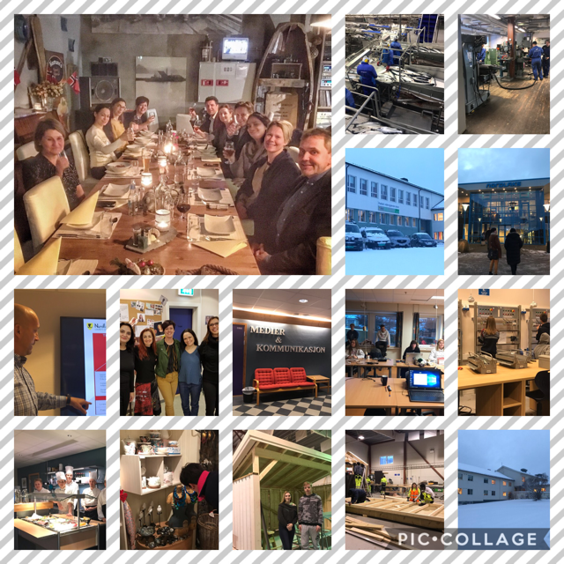
Partner schools
Ayse Dogan Mesleki Ve Teknik Anadolu Lisesi
Colegiul National Tudor Vladimirescu
Escola Básica 2o 3o Ciclos Cónego João Jacinto Gonçalves de Andrade
Hadsel videregående skole og fagskole
IES Nicolás Salmerón y Alonso
Liceo Statale Giovanni Cotta

