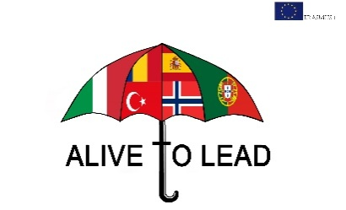

“How to become a leader?”
“A good leader represents the characteristics of honesty, courage, selfconfidence, wisdom and so much more. Honesty means having a heart to see the truth in every lie, courage means speaking without problems from your heart, acting on what he say he’s going to do and doing things to help people who lost the courage to stand up for their dreams. Wisdom means understanding how people thinks and what matters to them and of course, the ability to see possibilities in every action. As a leader, I believe strongly in people’s capacity and I easily see a way to make a connection between motivation and action. And I think that communication is the most important quality of a leader.”

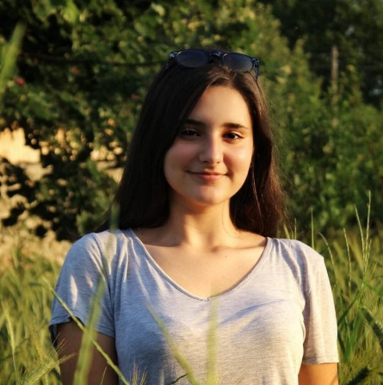
Tuvene Alexia Teodora-
leader of class X A
“For me, being a leader is being someone that people can trust to build them up, influence other decision-makers, listen to the people who choose to follow, and do my best to strengthen a team. A leader is someone who influences - both the people who choose to follow and the people outside of the “follower” group who interact with the leader. I am a leader of a German association called Gutenberg and I learned all of this in just one year and I am still learning about what a true leader really is, hoping that some day I will become the perfect one.”
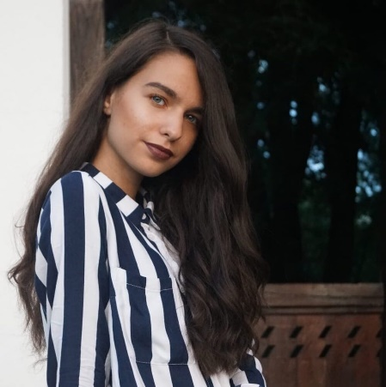
Trufelea Laura-
leader of Gutenberg association

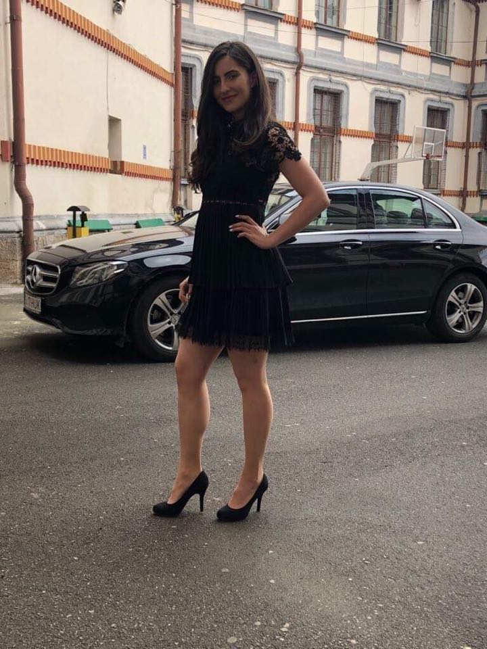
“I can link the word Leader to my participation in the German Olimpiadin 2017. On that occasion, we had moments of feeling hopeless and one of the girlsin my team even wanted to quit. Weall had to cope with different challenges to build a play based on a German novel we read those days. One day I noticed that the team was discouraged, so I decided to do something. Not only did I tell them that we could do it, but also made them overcome that moment by helping them with solutions. We worked hard, but also had fun and in the end I realized we were REAL TEAM. When we found out the results I understood that a realLEADER has to build a TEAM.
Dragotă Diana-Andreea
leader during national German Olimpiad

“Being a leader is ,besides a prestige, a great responsibility. A leader is responsible for people around him, and his presence and influence must be felt even in his absence. He needs to know how to consolidate the group and keep it united in any kind of situation. He has the power to change people around for the better and to make them evolve, and to ensure that things work well in theteam, he has to make sure that every person is heard and understood correctly. Under no circumstances should a leader make decisions without consulting those around him because he worksfor his team, not just for himself .In conclusion, I believe that the leadership position of a team is as beautiful as it is demanding because it involves much patience, much understanding and much responsibility.”
SimescuAndrada- leader of class X G

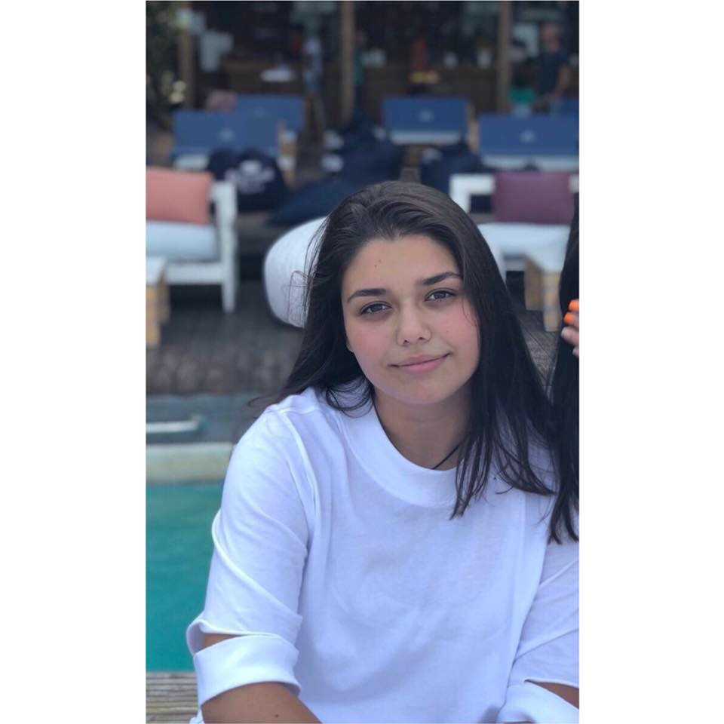
“I am a leader of a dance group called Brothers Crew and I learned over the past three years that being a leader is not that simple, especially in my case where I have to teach each person some pretty hard dance moves.But a true leader focuses on the people around him or her, serves, and encourages the people with whom they come in contact, and takes responsibility. A leader helps to managing conflicts, understand themselves, and understand the others . A leader isn’t perfect, but is approachable, teachable, and willing to work.”

Rogobete Nicola- leader of a dance group

“Leadership doesn’t have a one sizethat fits all solutions, and there is no magic formula that will instantly make you a great leader. Instead it takes time and dedication to learn how to achieve the goals you set, and how to inspire others to follow you and do the same. Everyone has their different ways of doing this, whether it’s through rewards, allowing more freedom within job roles or getting stuck in to the job alongside your employees. Each approach works differently for everyone, but each type of leader has taken time to figure out their style.”

StroieDrgoș- leader of the theater team

“Leaders are not born, they are trained.”
To be a good leader, you must be a good follower. A leader shows a positive example, it is not just a position carrying in his shoulder!”
Tașcău Răzvan- leader of class X C

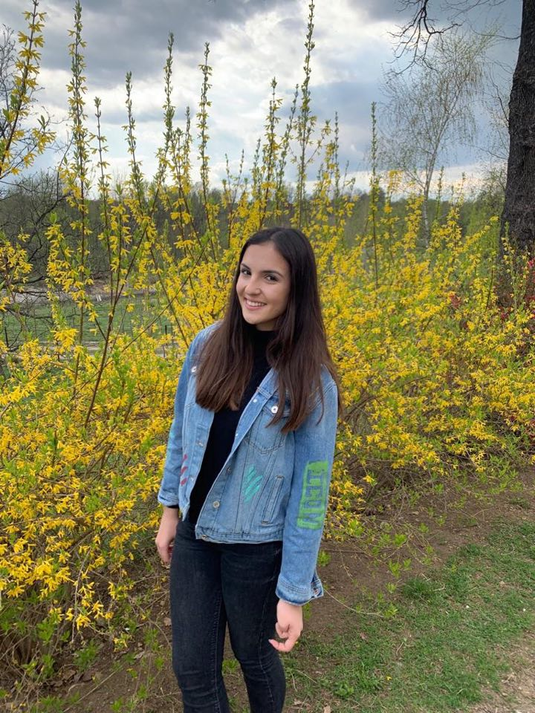
„Tobe an effectiveleader, one must beabletoinfluenceotherstoaccomplishgoals, tocontributetotheorganizationandcohesion of a group. Leadership isnotaboutusingpositionalpowerto drive peopletomeetobjectives. It istheabilitytobringtogetherthe team sothattheycanseethevalue of theendresultthatneedstobeachieved. Thiswaytheactionstheytake are drivenby a biggerpurpose.”
Gheorghescu Anastasia- leader of class X E

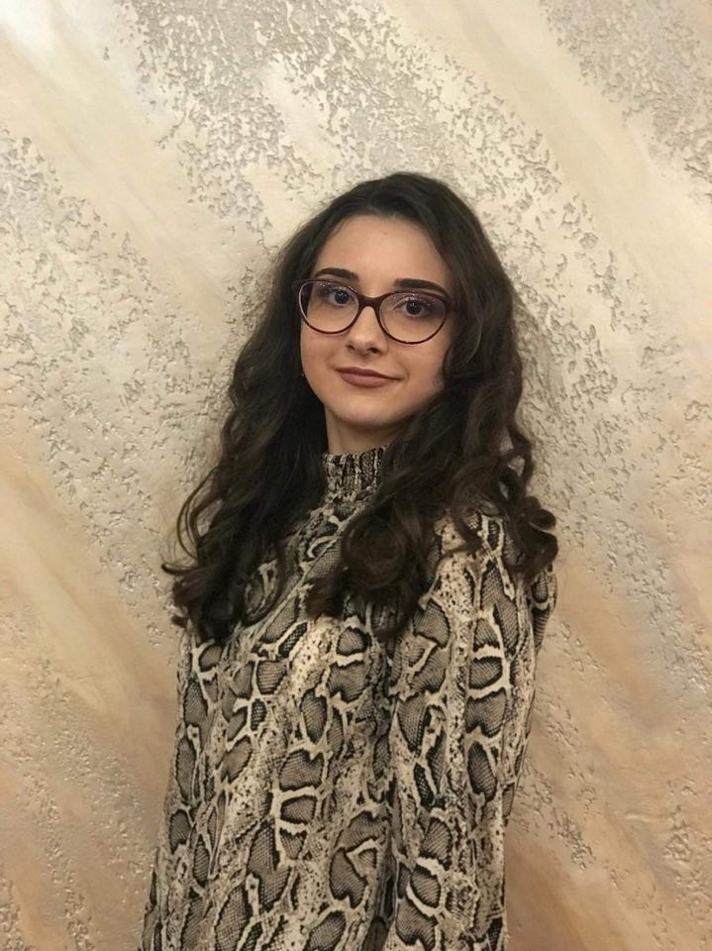
“A good leader is a person always open to opinions, thoughts, wishes and all the problems of his team. To be understood, to have a distinct atmosphere between teammates, the leader must not seem to be superior to others, not to present his duties as commandments, without making his own subordinates slaves, for the sake of being close to them, considering them friends.
In a community, the leader has to help them, guide the people around him, give them advice, ideas for the final work to be a perfect one.”
Ripanu Raisa- leader of class X B

“Being a good leader isn’t all sunshine and rainbows. Sometimes you will have to make difficult or unpopular decisions, or maintain your positivity even when you don’t really believe it. This is where your leadership mindset will be the difference between mediocre and exceptional leadership.”
Mignea Alexandru- leader of class X B

