ERASMUS+ ALIVE ANTI BULLYING POSTERS
Throughout the ERASMUS+ALIVE project, our high school has organized an “anti bullying posters “contest. Some of our students worked in teams or separately and all of them tried to have the most beautiful poster.Here are our results:
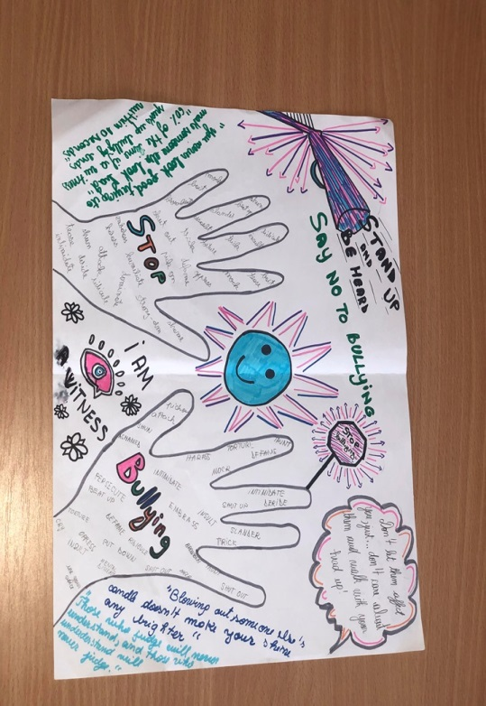
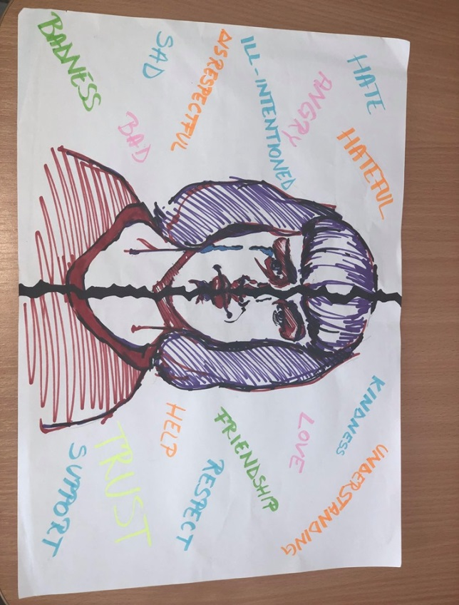
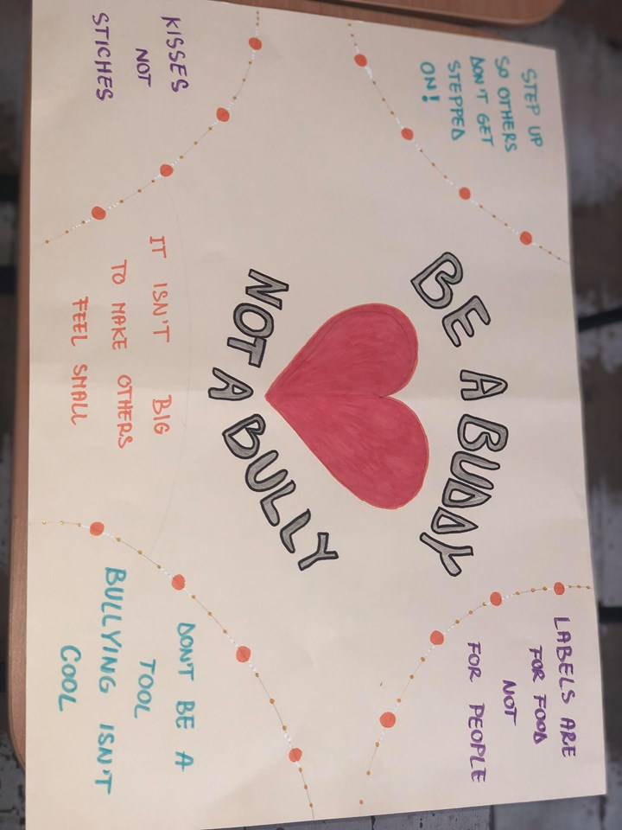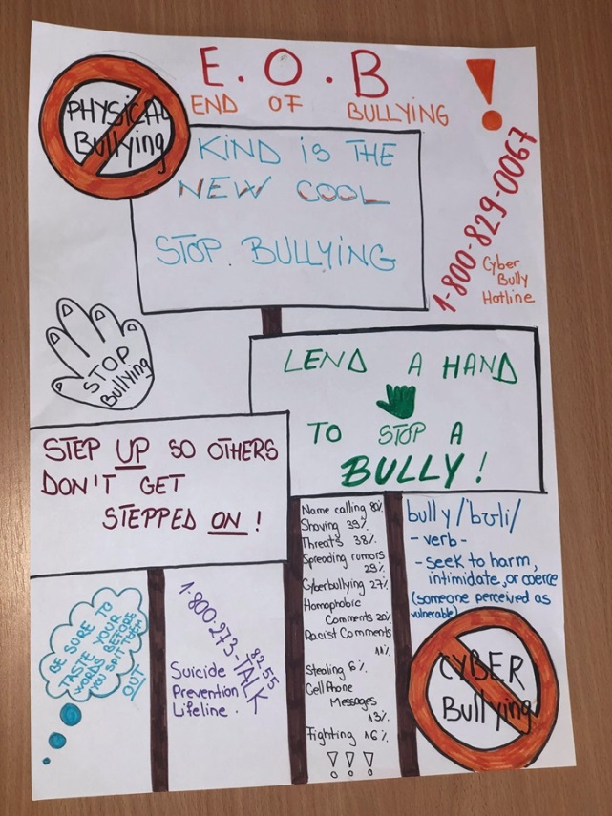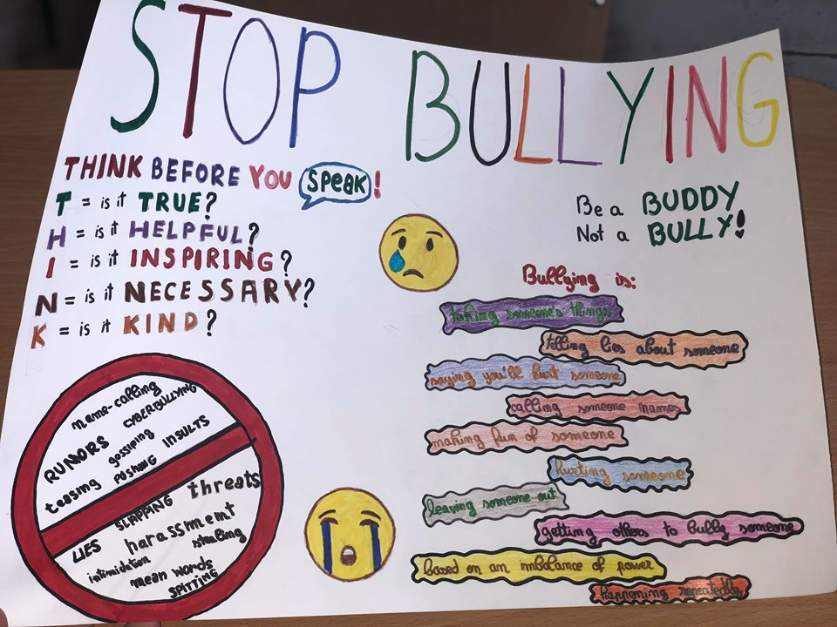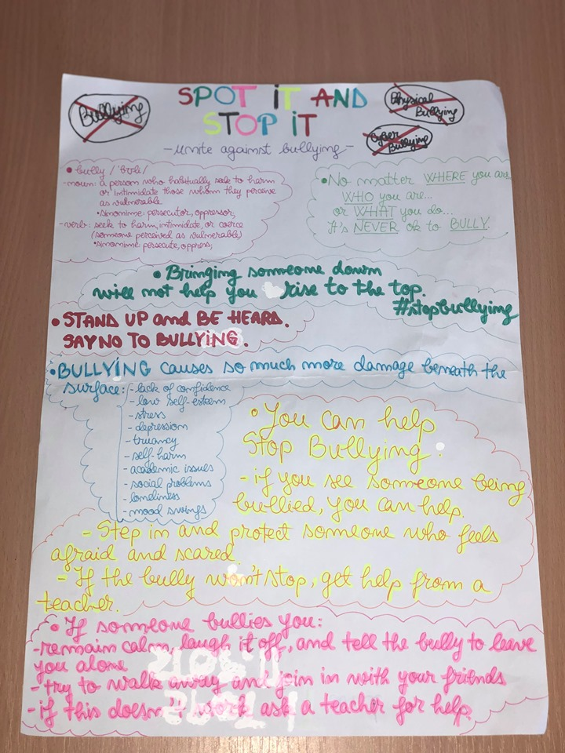
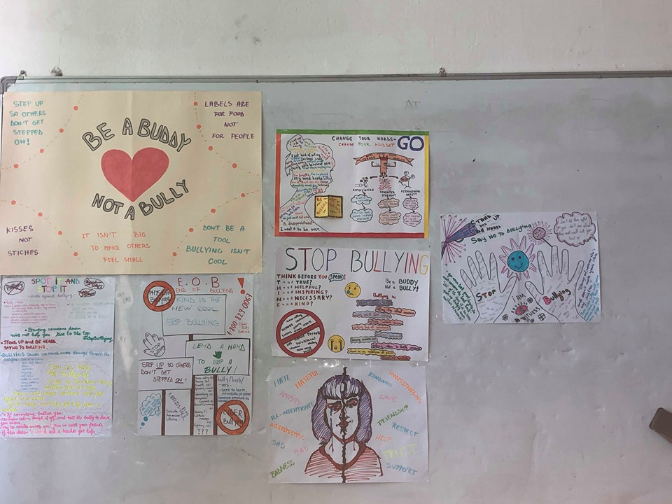
In the end, we had to choose only one winner even if they all worked hard and all of them were really good. We organized an activity dedicated to this project during our high school activity “The White Night” and all the kids from our high school came to vote the best project.

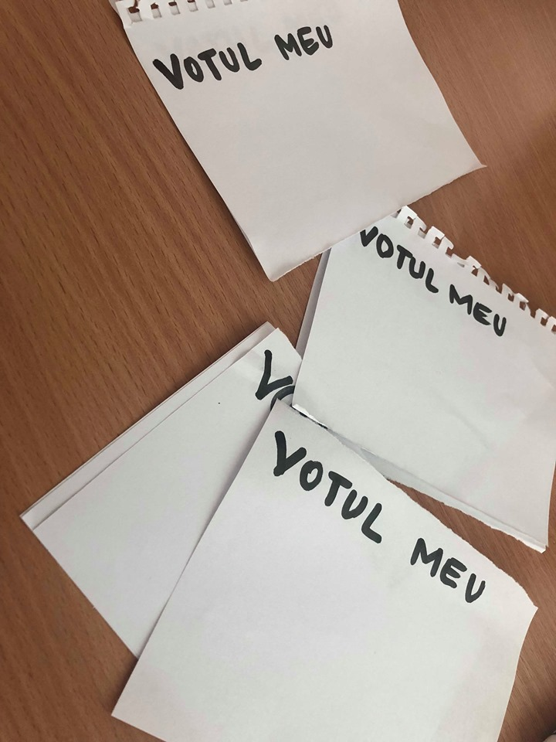
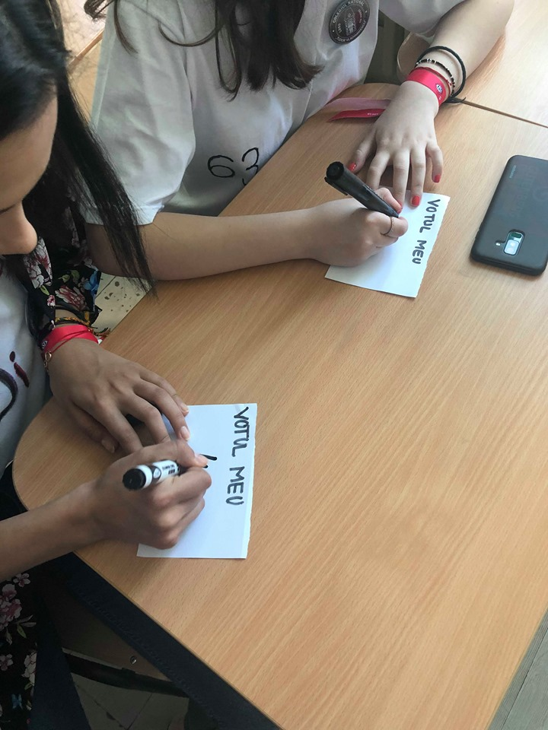

We counted all the votes and even if the score was tight,we had a winner. We were all glad to be part of this activity and we had fun working together!
The winner was the next one made by Trufelea Laura Andreeafrom class XA.

